



**PROJECT REPORT ON**

**“** Design and Development of Robotic Arm Using MATLAB and Simulink Based on Robot Kinematics**”**

Submitted By,

**Mrs. Nikita Ravindra Dhuppe.**

**Mrs. Vaishnavi Ramrao Urmunge.**

**Mr. Shubham Sudam Palkar.**

**Mr. Mahesh Balkrishna Ghuge.**

**Mr. Bhadoriya Aryan Singh.**

Under The Guidance of

**Mr. G.R.Barse**

Department of Electrical Engineering

2023-2024





Department Of Electrical Engineering

**CERTIFICATE**

This is to certify that “**Mrs. Nikita Ravindra Dhuppe (2020BEL004), Mrs.Vaishnavi Ramrao Urmunge (2020BEL006), Mr. Shubham Sudam Palkar (2020BEL011), Mr. Mahesh Balkrishna Ghuge (2020BEL030), Mr. Bhadoriya Aryan Singh (2020BEL032)”** students of B.Tech. Electrical Engineering have submitted project report on “Design and Development of Robotic Arm Using MATLAB and Simulink Based on Robot Kinematics”for partial fulfilment of the requirement on the course work Project I in Electrical Engineering. In this volume, they have submitted a satisfactory report during academic year 2022-2023.

Mr. G.R.Barse Prof. V. G. Asutkar

Project Guide Head of Dept.

* **ACKNOWLEDGMENT**

The satisfaction and euphoria that accompany the successful completion of any task would be incomplete without the people who made it possible, whose constant guidance and encouragement crowned our efforts with success.

We would like to thank prof. V. G. Asutkar, HOD Of Electrical Engineering Department for his valuable guidance.

We would like to thank prof. G.R.Barse of Electrical Engineering Department. For her stimulating guidance, suggestions and encouragement in successful completion of this technical task.

Finally, we would like to immensely thank all our friends and all staff members whose encouragement and suggestion helped us to complete our project. We are also thankful to all those persons, who have contributed directly or indirectly in the completion of this project.

* **ABSTRACT**
* In the era of 4.0 technology, robotic arms are becoming more and more popular in modern industries. Therefore, the research and simulation of robotic arms mean a lot in improving the efficiency of using this tool in all sectors.
* The project aims to design, develop, and implement a versatile robotic arm system tailored for industrial automation applications.
* This project addresses the increasing demand for efficient and adaptable automation solutions in modern manufacturing environments.
* The robotic arm incorporates advanced sensing, control, and manipulation capabilities, enabling it to perform a wide range of tasks with precision and reliability.

**TABLE OF CONTENTS**

|  |  |  |
| --- | --- | --- |
| **Chapter No.** | **Topics** | **Page No** |
|  | **COVER PAGE** |  |
|  | **CERTIFICATE** | **i** |
|  | **ACKNOWLEDGEMENT** | **ii** |
|  | **ABSTRACT** | **iii** |
|  | **TABLE OF CONTENT** | **iv** |
|  | **INTRODUCTION** | **1** |
| **1** | **LITERATURE SURVEY** | **2** |
| **2** | **PROBLEM STATEMENT** | **3** |
| **3** | **COST OF COMPONENTS** | **4** |
| **4** | **PROPOSED SYSTEM** | **5** |
| **5** | **COMPONENTS** | **6** |
| **6** | **CAD MODEL** | **12** |
| **7** | **SIMULATION IMAGE** | **12** |
| **8** | **FUTURE SCOPE** | **13** |
| **9** | **ADVANTAGES** | **13** |
| **10** | **REFERENCES** | **14** |

**INTRODUCTION**

* Today, along with the development of information technology and mechanics, robots have become more widely used in all production processes, improving manufacturing efficiency, increasing productivity, enhancing working conditions, and accelerating industrial automation .
* The robotic arm has also been widely used in the medical field, besides its applications in high temperature, high pressure, dust, noise, radiation, and polluted environments. Additionally, robotic arms are used in the automotive industry for welding, painting, loading, and unloading .
* The robot arm can also replace workers in harsh environments, replace human labor who do heavy, monotonous, and repetitive work, improve labor productivity, and ensure product quality.
* Its applications have been extended to space exploration, marine bed research, nuclear science research, or automated medicine operations. Therefore, it can be confirmed that the robotic arm is a key technology in automatic control and has become an important part of modern industrial systems.
* The robotic arm contains an operator, a controller, a servo drive system, detection .

**1.LITERATURE SURVEY**

* **Robotic Arm Control System Based on Al Wearable Acceleration Sensor( 03 Mar 2021)**

With the development of science and technology, many practical production requirements for the furetion of the manipulator are more and more refined, especially in the high-end research field. This paper mainly introduces the research of manipulator control systent based on Al wearable acceleration sensor, aiming to provide some ideas and directions for the research of wearable mampalator

* **Design of a 4 DOE parallel robot arm and the firmirare implementation on embedded system to transplant pot seedlings 2020**

The paper presents a firmware design and its implementation of aal time embedded system for driving a DOF parallel shot arm. The firmware manly comprised of two components to produce motion of the robot arm

* **An Arduino Robot Arm which can be wirelessly controlled a id programmed using a custom-buildAndroid application. Using the sliders in the app we can manually control the movement of each servo or axis of the robot arm. Also using the "Save" button we can record each position or step and then the robot arm can automatically run and repeat these steps.**

**2.PROBLEM STATEMENT**

"Design and construct a versatile robotic arm capable of performing precise and controlled movements to accomplish a range of tasks in various environments. The arm should exhibit flexibility, accuracy, and efficiency in tasks such as picking and placing objects, assembly operations, and controlled movements in constrained spaces”.

**3. LIST & COST OF COMPONENTS**

|  |  |
| --- | --- |
| Metal Gear Servo Motor RDS5180 x 1 | **7149** |
| Servo Motor MG995 x 2 | **650** |
| TowerPro SG92R Mini Servo Motor (180°) x 2 | **300** |
| 16-Channel 12-bit PWM/Servo Driver I2C interface PCA9685 x1 | **300** |
| Arduino Mega x 1 | **1325** |
| Arduino Nano 33 IoT ( If valid) x 1 | **1899** |
| Miscellaneous ( Nuts, Bolts, Wires, etc.) | **500** |
| 3D Printer |  |
| Battery |  |
| **Total** |  |

**4.PROPOSED SYSTEM**

**5.COMPONENTS:**

Following components are used in this project:

* **Metal Gear Servo Motor RDS5180 :**



**Description:**

These Dual Shaft Servo motors are great for applications where output positional control is required. The shaft can be moved to any required angle using a PPM signal. Servo motors are the easiest-to-use motors as they do not require external motor drivers, feedback sensors, etc. Just connect it to your microcontroller to a Digital IO pin and you can start controlling the servo motor. It is water resistant and features high torque, metal gear, fast heat dissipation, sensitivity, and responsiveness.

* **Specifications:**
* Size:65*30*48mm(servo)
* Wire length:300mm
* Operating Voltage: 6V-8.4V
* Gear Type: Copper & Aluminum
* Bearing: Double Bearing
* Weight: 162g
* **Servo Motor MG995:**

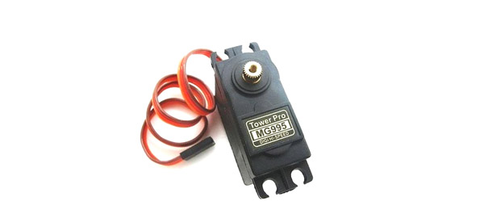

MG995 is a servo motor providing precise rotation over 180º range its applications are many

The servo is suited for designing robotic arm in which wear and tear of motor is high. Being metal geared, the servo has long life and can be installed on system like robotic arm were motor work is huge.

* **Specifications:**
* High speed rotation for quick response
* Constant torque throughout the servo travel range
* Weight: 55 g
* Operating voltage range: 4.8 V to 7.2 V
* Operating speed: 0.2 s/60º (4.8 V), 0.16 s/60º (6 V)
* Rotational degree: 180º
* Current draw at idle: 10mA
* Current at maximum load: 1200mA
* **TowerPro SG92R Mini Servo Motor**

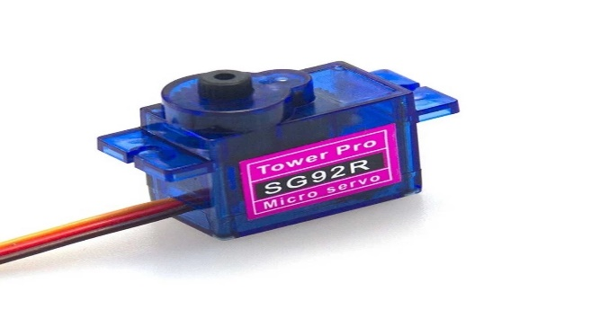

TowerPro Servo Motors are optimum-quality and affordable cost servos and are suitable for a wide range of applications, including RC aircraft, automobiles, and robotics

* **Specifications:**
* Operating Voltage (VDC) = 3.0 ~ 7.2
* Operating Speed @4.8V = 33515
* Operating Temperature (°C) = -30 to 60
* Weight(gm) = 9
* **16-Channel 12-bit PWM/Servo Driver I2C interface PCA9685**
* If you want to make a robot which has lots of moving parts or if you want to control too many LEDs with **PWM** outputs,  then the limited **PWM** outputs of your microcontroller would be a big problem for you. To overcome this problem, the only thing you should do is to get a[**16-Channel 12-Bit PWM/Servo Driver**](https://robu.in/product-tag/16-channel-servo-driver/).



* **Specifications :**
* Driver IC = PCA9685
* Length(mm) = 62
* Width(mm) = 25
* Height(mm) = 15
* Weight (gm) = 10
* . **Arduino Mega**



* The **Arduino Mega 2560** is a microcontroller board based on the [ATmega2560](http://ww1.microchip.com/downloads/en/DeviceDoc/Atmel-2549-8-bit-AVR-Microcontroller-ATmega640-1280-1281-2560-2561_datasheet.pdf). It has 54 digital input/output pins (of which 15 can be used as PWM outputs), 16 analog inputs, 4 UARTs (hardware serial ports), a 16 MHz crystal oscillator, a USB connection, a power jack, an ICSP header, and a reset button.
* **Specifications :**
* Operating Voltage = 5V
* Input Voltage = 7-12V
* Digital I/O Pins = 54 (of which 15 provide PWM output)
* Analog Input Pins = 16
* DC Current per I/O Pin = 20 mA
* DC Current for 3.3V Pin = 50 mA
* Flash Memory = 256 KB of which 8 KB used by bootloader
* SRAM = 8 KB
* EEPROM = 4 KB
* Clock Speed = 16 MHz
* **Arduino Nano 33 IoT**



* The Arduino Nano 33 IoT is the easiest and cheapest point of entry to enhance existing devices (and creating new ones) to be part of the IoT and designing pico-network applications. Whether you are looking at building a sensor network connected to your office or home router, or if you want to create a Bluetooth® Low Energy device sending data to a cell phone, the Nano 33 IoT is your one-stop-solution for many of the basic IoT application scenarios.
* **Specifications**
* Operating Voltage = 3.3V
* Input Voltage (limit) = 21V
* DC Current per I/O Pin = 7 mA
* Clock Speed = 48MHz
* SRAM = 32KB
* Digital Input / Output Pins = 14
* Length = 45 mm
* Width = 18 mm

* **JUMPER WIRES:**

A jump wire (also known as jumper, jumper cable, Du Pont wire) is an electrical wire, with a connector or pin at each end which is normally used to interconnect the components of a breadboard or other prototype or test circuit, internally or with other equipment or components, without soldering. Individual jump wires are fitted by inserting their end connectors into the slots provided in a breadboard, the header connector of a circuit board, or a piece of test equipment.

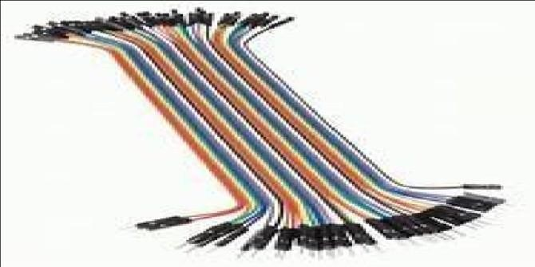 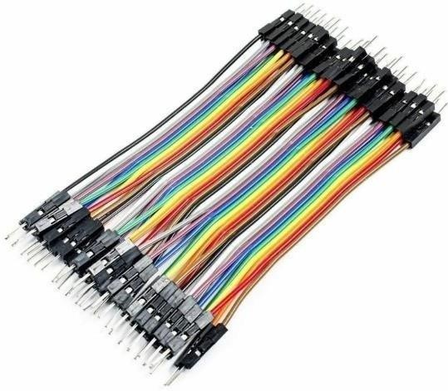

.

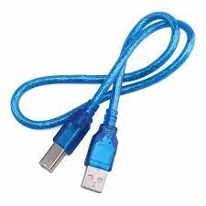

**6.CAD MODEL**

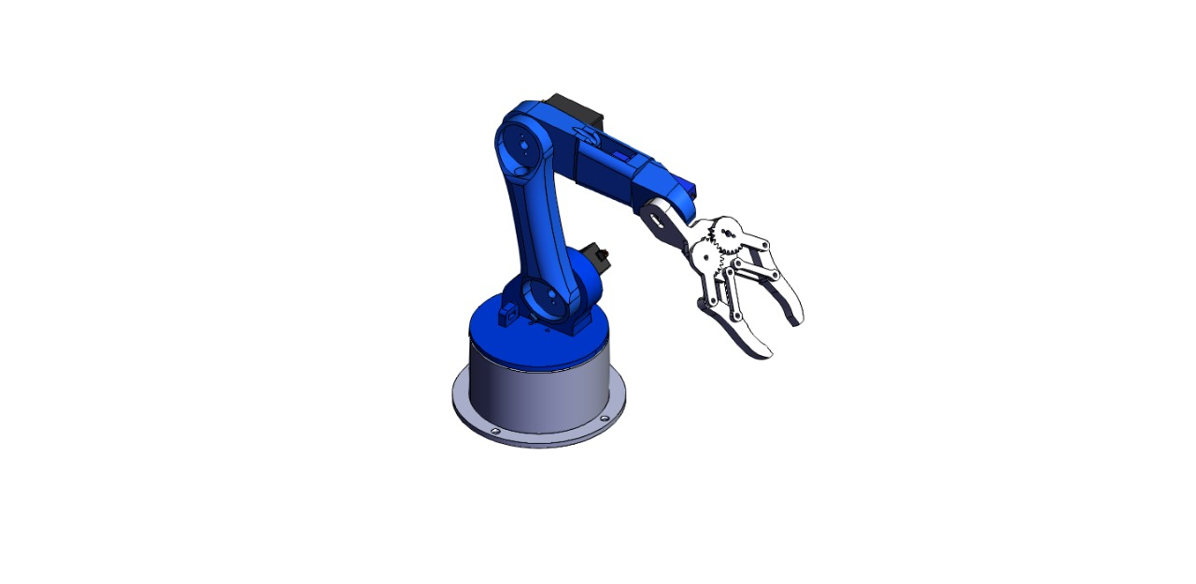

**7.SIMULATION MODEL**

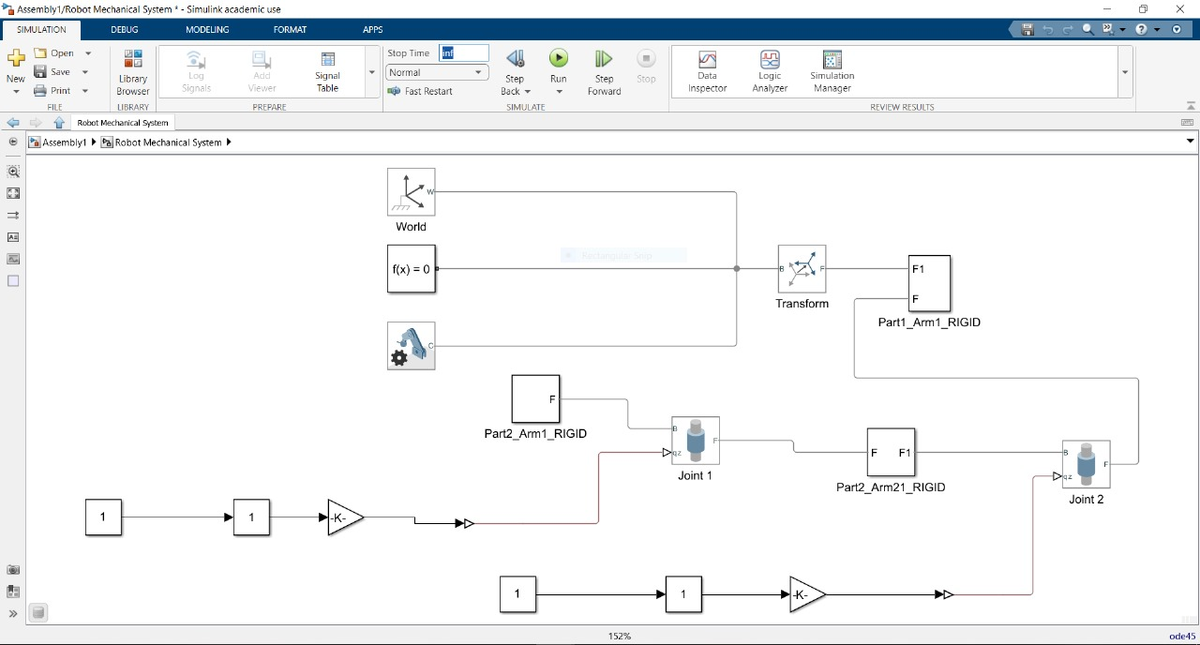

**8.ADVANTAGES:**

* Cost Effectiveness: There will be no lunchbreaks, holidays, sick leave or shift time allocated for robotic.
* Improved Quality Assurance: Robotic automation eliminates the risks of vigilance decrement by accurately producing and checking items meet the required standard without fail
* Increased Productivity : Due to continuous and stress less work the production will take place continuously and wil boost the production.
* Work In Hazardous Environments: If a high level of chemicals are present, robotic automation offers the ideal solution, as it will continue to work without harm, even in areas that have extremely high or low temperatures Robotics will prove themselves the best.

**9.Future Scope**

* Machine Learning and AI Integration
* Human-Robot Interaction
* Medical and Healthcare Applications
* Autonomous Manufacturing and Industry
* Agricultural Robotics

**9.REFERENCES:**

* Iqbal, Jamshed, R. Ul Islam, and Hamza Khan, "Modeling and analysis of a 6 DOF robotic arm manipulator", Canadian Journal on Electrical and Electronics Engineering 3, no. 6, pp. 300-306, 2012
* H. C. Nguyen, "Research on the application of Neural Networks in identification and control of the robotic arms-A nonlinear dynamic object," Journal of Science and Technology – the University of Da Nang
* Meng, Wei, Quan Liu, Zude Zhou, Qingsong Ai, Bo Sheng, and Shengquan Shane Xie, "Recent development of mechanisms and control strategies for robot-assisted lower limb rehabilitation,"
* https://www.researchgate.net/publication/320174036_Design_and_development_of_a_robotic_arm